Switching and Wireless Skills Based Assessment
Mock Exam Using Packet Tracer
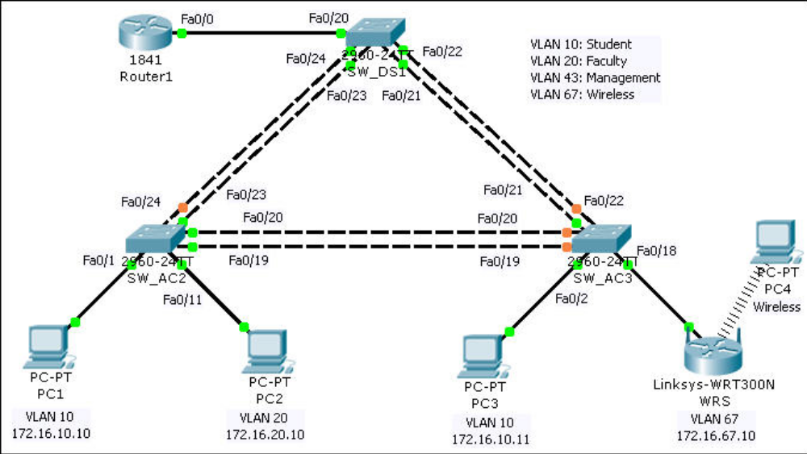
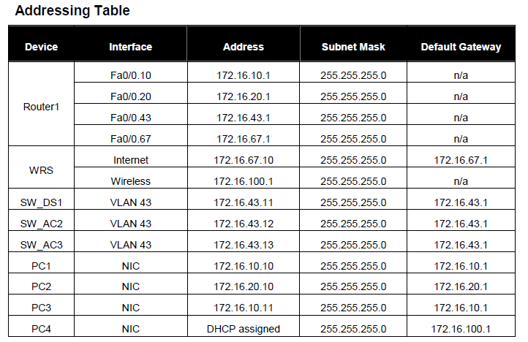
Note: The password for user EXEC mode is cisco. The password for privileged EXEC mode is
class.

- Device Connection
The student can connect switches and hosts in a wired LAN.

- Basic Device Configuration
The student can create a basic switch IOS configuration including naming, banner, passwords, management interface addressing and default gateway configuration

- Trunk Configuration
The student can configure and verify trunking.

- VTP and VLAN Configuration
The student can configure and verify VTP. The student can configure and verify VLANs.

- VLAN Access Configuration.
The student can configure and verify VLANs

- Inter-VLAN Routing Configuration
The student can configure and verify inter-VLAN routing

